**Linux Administration Course**

Linux is an open source Operating system.Used in mainframes,servers and embedded devices.

**Linux Distributions**

**Choosing a Linux Distro**

|  |  |
| --- | --- |
| **Distribution** | **Why To Use** |
| UBuntu | It works like Mac OS and easy to use. |
| Linux mint | It works like windows and should be use by new comers. |
| Debian | It provides stability but not recommended to a new user. |
| Fedora | If you want to use red hat and latest software. |
| Red hat enterprise | To be used commercially. |
| CentOS | If you want to use red hat but without its trademark. |
| OpenSUSE | It works same as Fedora but slightly older and more stable. |
| Arch Linux | It is not for the beginners because every package has to be installed by yourself. |

**When Ubuntu fit and when it’s not**

<https://www.softwaretestinghelp.com/ubuntu-vs-windows/#Disadvantages-2>

**How to keep your system up to date ?**

ubuntu-security-status -support duration of your current [Ubuntu installation](https://linuxconfig.org/how-to-install-ubuntu-22-04-jammy-jellyfish-desktop) with the following command:

lsb_release –a : what version of Ubuntu you’re running

sudo apt update : to update the packages

apt list –upgradable: which packages are due for an update

apt install PACKAGE-NAME : To update individual package.

sudo apt upgrade-Update all packages

sudo apt dist-upgrade:Dependencies Packages to update

sudo apt autoremove: No longer needed package gets removed

**What Shell’s are?**

The shell is the Linux command line interpreter. It provides an interface between the user and the kernel and executes programs called commands. For example, if a user enters ls then the shell executes the ls command.

**Essential Bash Commands**

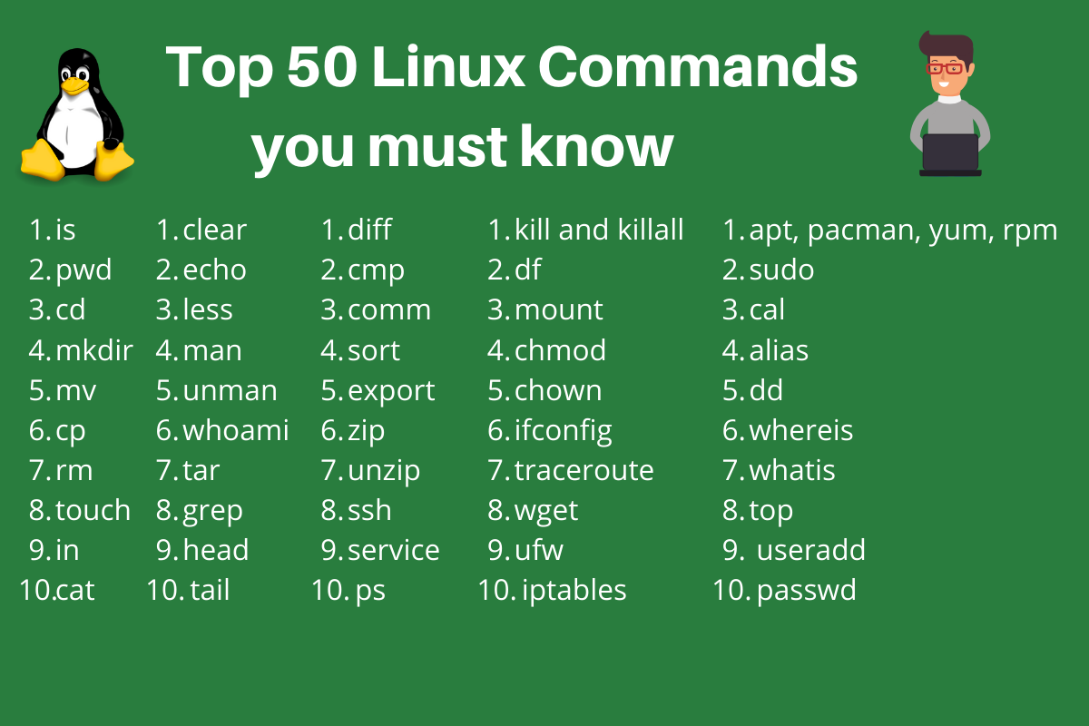

ls - The most frequently used command in Linux to list directories and files

pwd - Print working directory command in Linux

cd - Linux command to navigate through directories

mkdir - Command used to create directories in Linux

mv - Move or rename files in Linux

cp - Similar usage as mv but for copying files in Linux

rm - Delete files or directories (rm-r:to delete directories)

touch - Create blank/empty files(

ln - Create symbolic links (shortcuts) to other files

cat - Display file contents on the terminal

clear - Clear the terminal display

echo - Print any text that follows the command

less - Linux command to display paged outputs in the terminal(one page at a time)

man - Access manual pages for all Linux commands

uname - Linux command to get basic information about the OS

whoami - Get the active username

tar - Command to extract and compress files in Linux(-cvf,-xvf)

grep - Search for a string within an output

head - Return the specified number of lines from the top(

tail - Return the specified number of lines from the bottom

diff - Find the difference between two files(number of lines)

cmp - Allows you to check if two files are identical

comm - Combines the functionality of diff and cmp

sort - Linux command to sort the content of a file while outputting

export - Export environment variables in Linux

zip - Zip files in Linux

unzip - Unzip files in Linux

ssh - Secure Shell command in Linux

service - Linux command to start and stop services

ps - Display active processes

kill and killall - Kill active processes by process ID or name

df - Display disk filesystem information(available space)(df –h)Will display Human Redable

mount - Mount file systems in Linux

chmod - Command to change file permissions

chown - Command for granting ownership of files or folders

ifconfig - Display network interfaces and IP addresses

traceroute - Trace all the network hops to reach the destination

wget - Direct download files from the internet(wget –c)

ufw - Firewall command

iptables - Base firewall for all other firewall utilities to interface with

apt, pacman, yum, rpm - Package managers depending on the distro

**Debian and Debian-based distros** - apt install <package name>

**Arch and Arch-based distros** - pacman -S <package name>

**Red Hat and Red Hat-based distros** - yum install <package name>

**Fedora and CentOS** - yum install <package>

sudo - Command to escalate privileges in Linux

cal - View a command-line calendar(Calendar Command)

alias - Create custom shortcuts for your regularly used commands

dd - Majorly used for creating bootable USB sticks

whereis - Locate the binary, source, and manual pages for a command

whatis - Find what a command is used for

top - View active processes live with their system usage

useradd and usermod - Add new user or change existing users data

passwd - Create or update passwords for existing users